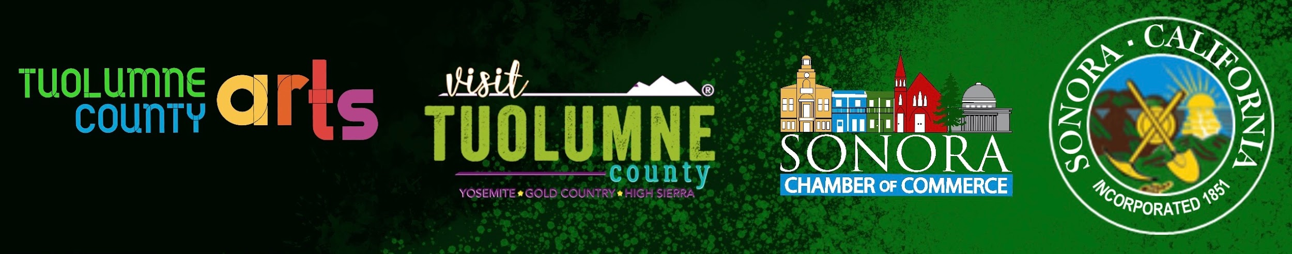

So Beautiful
Community Beautification Pilot Program

OVERVIEW
This project is a cooperative effort between the City of Sonora, Visit Tuolumne County, the Sonora Chamber of Commerce, and Tuolumne County Arts. Together, we are proud to launch So Beautiful: Community Beautification Pilot Program—an initiative designed to transform unsightly storefronts along Washington Street and throughout the downtown corridor into vibrant, eye-catching artworks that showcase the golden talent of our local artists.
The program celebrates Sonora’s artistic spirit by reimagining downtown windows as a welcoming, walkable arts experience for both community members and visitors. So Beautiful gives local artists a visible platform to share their authentic points of view.
As part of the City of Sonora’s ongoing commitment to revitalizing the downtown district, this project brings together property owners, artists, and cultural partners to transform vacant or underutilized spaces into opportunities for beauty, creativity, and community engagement.
Through this effort, we aim to not only brighten our streetscape but also foster a sense of pride, cultural identity, and connection—making downtown Sonora a destination that reflects the richness of its people and the vitality of its arts.
How it works:
- Artists must reside in Tuolumne County
- Artists can submit up to two works and will upload digital copies of original pieces of art via the process outlined below. Only one will be selected.
- Selected artists whose work is installed will receive a $250 honorarium.

Artist guidelines for submitting work
- Artwork submissions must be original, and artists must hold full rights of the work to submit their work. No clip art, A.I. or potential copyright infringements please.
- Submissions must be digital via SmarterEntry. There will be NO entry fee for this program. Rules below.
- Work should showcase quality, unique point of view, celebrating the richness of its people and the vitality of its arts.
- All work must be family-friendly and intended to beautify vacant storefronts.
- No advertising, or signage elements may be included.
- Original Images must be scalable for large-format printing
- Artwork may need to be cropped, modified, framed with additional elements, and formatted to fit the space. Please note window sizes vary in location.
Who May Apply
- Artists must reside in Tuolumne County
- Must be 18 or over.

Selection Process & Honorarium:
- Submissions will be reviewed by appointed City of Sonora, the ad hoc Arts Committee and stakeholders.
- Selected works will be submitted to SmarterEntry for review.
- There will be no entry fee for this program.
- If your work is matched to a storefront installation, you will receive a $250 honorarium.
- Artist information and credit will be incorporated into the final display using design QR codes “sticker” will be utilized for linking to artist websites, Instagram or other social media.
- Art in storefronts will be revealed on a rolling timeline in conjunction with Second Saturday art nights as budget permits.

Timeline
- Call opens October 1st, 2025. 9:00 am
- Call Closes: Nov 10th, 2025, at 9:00 pm.
- All Artists will be notified by December 1, 2025, of the artworks selected.
- Potential for additional phases in the future.

RULES
Each artist may submit up to two (2) works for consideration. Only one will be selected.
- Go to : https://client.smarterentry.com/tcaa2
- Create an account.
  - They will ask for credit card information but there will be no entry fee for this program.
- Select the “So Beautiful” competition after October 1, 2025
- Submit your saved images
  - Your original images should be large enough to enlarge for our use.
  - Make a copy of your original photo to apply the resizing criteria
  - File size no smaller than 4 mb and no larger than 8 MB.
  - To resize: Set image resolution first to 300 ppi.
Size to 1,280 pixels on the longest side with the other side, width or height, proportional. A smaller size may result in an image too small for the judges to properly view.
  - Save as a JPG (creates the smallest file size), TIF, or PNG format​
  - Use the naming convention as follows: PieceName_ArtistName.
Artists Statement should include:
- Your name and title of your piece. Please add this information EXACTLY as you would like shown to the public, down to upper and lower case, spelling, etc.
- Your legal name for honorarium check.
- Description of image. 100 Characters maximum.
- Artist website Instagram, gallery, store, link tree*

QUESTIONS:

SmarterEntry Admin contact: contests@tuolumnecountyarts.org

General questions may be directed to Arts Program Admin: bonbon@tuolumnecountyarts.org

Downtown Sonora Building owners and Businesses interested in hosting art as part of revitalization program please contact: bonbon@tuolumnecountyarts.org

Licensing & Usage​

EXAMPLE
By submitting, artists grant So Beautiful a license to digitally reproduce selected works for the purposes of the Community Beautification Pilot Program. If selected the artist will be required to submit a signed copy of this waiver.
Digital Reproduction Release-
By submitting to the Beautification Program Artist Call, artists agree to the digital reproduction of selected artworks by the City of Sonora, Visit Tuolumne County, Sonora Chamber of Commerce and Tuolumne County Arts for the purposes of artwork reproduction for the So Beautiful: Community Beautification Pilot Program. As the artist, l also consent and authorize references to my work for the purposes of advertising the program as well as my likeness in connection with the exhibition, distribution, and publicizing of images by the City of Sonora, Visit Tuolumne County , Sonora Chamber of Commerce and Tuolumne County Art. Artists who submit hereby release and discharge the above organizing entities and its affiliates from any all claims, actions, suits or demands in connection with the use of images for the above purposes. Artists waive the right to inspect or approve the use of reproductions of accepted artwork for reprinting for the So Beautiful community Beautification Program.
I agree __________
Sign Here ____________
Submitted on date _________

